

Multi-Branch Operation System (MBOS)

Project Documentation Submitted to the Faculty of the

School of Computing and Information Technologies

Asia Pacific College

In Partial Fulfillment of the Requirements for

Introduction to Systems and Design for CS/IT

M/S NTSDEV

By

|  |  |
| --- | --- |
| John Rex Merencillo | Ashly Jude Degala |
| Julian Sebastian Mistica |  |

2024

Table of Contents

Executive Summary i

List of Figures ii

List of Tables iii

I. Introduction 1

1.1 Project Context 1

1.2 Statement of the Problem 2

1.3 Objectives 2

1.4 Significance of the Project 2

1.5 Scope and Limitations 3

II. Review of Related Literature / Systems 4

III. Current Systems 6

3.1 Current System 6

3.2 Technical Background 6

3.3 List of Processes 6

3.4 Gap Analysis 8

IV. Proposed Solution 10

4.2 Lean Canvas 10

4.3 Product Vision 11

4.4 Technology Specifications 11

4.5 Feasibility 13

V. Requirements Analysis 14

V.1 Product Backlog / User Stories 14

V.2 Use Case Diagram 17

V.3 User Classes and Characteristics 18

V.4 Prototype 19

5.7 Release Plan 23

References 24

VII. 25

Appendices 25

Appendix A: Schedule/Release Plan 25

Appendix C: Teams Meetings 27

Appendix D: Users’ Manual 28

Appendix E: Teams Meetings 29

# Executive Summary

The proposed project, a Multi-Branch Operation System (MBOS) for Prettylooks Aesthetic, aims to centralize and streamline operations across all branches. This system will automate customer record management, appointment scheduling, and inventory monitoring. By addressing the current challenges of manual data handling and disparate systems, MBOS will enhance operational efficiency and improve customer service.

The expected benefits of MBOS include providing synchronized customer records, reducing errors and improving the customer experience. Aside from that, the system will automate scheduling and will minimize administrative burden, allowing staff to focus on client interactions. Enhanced inventory management will ensure real-time updates, preventing stock-outs and optimizing supply levels. These improvements will lead to better decision-making and service consistency across all locations.

The project is feasible operationally, economically, technically, and within a reasonable timeframe. Operationally, it is supported by the management and aligns with the business goal of improving service delivery. Economically, the project promises a positive return on investment through increased efficiency and customer satisfaction. Technically, the project can be implemented using standard development tools and secure cloud-based infrastructure.

Implementing MBOS will significantly enhance Prettylooks Aesthetic Center operational efficiency and customer experience, ensuring consistent and high-quality service across all branches.

# List of Figures

Figure 1 Setting Appointment 7

Figure 2 Accommodating Walk-ins 7

Figure 3 Recording Supplies 7

Figure 4 Accommodating Customer from Another Branch 8

Figure 5 Contacting Factory for Product 8

Figure 6 Data Entry of Customer Records 8

Figure 7 Fishbone Diagram 8

Figure 8 Fishbone Diagram 9

Figure 9 Lean Canvas 10

Figure 10 Use Case Diagram 17

Figure 11 Sign-in 19

Figure 12 Home Page 19

Figure 13 Customer Records Page 20

Figure 14 Viewing a Customer Record 20

Figure 15 Editing a Customer Record 21

Figure 16 Customer Schedule Page 21

Figure 17 Viewing a Customer Schedule 22

Figure 18 Inventory Records Page 22

Figure 19 Generate Report Page 23

# List of Tables

Table 1 List of Processes 7

Table 2 Gap Analysis 11

Table 3 Product Vision 14

Table 4 User Stories 17

Table 5 User Classes and Characteristics 21

# Introduction

## Project Context

Prettylooks Aesthetic, owned by Susan Ong Dela Fuente, RPH, who has been personally trained by Asia’s No. 1 Master of Aesthetic Tattoo, has been a reputable aesthetics center operating for over 40 years since its establishment in 1983. With branches in Alabang, BGC, Granada, Ortigas, Quezon City (Il Terrazzo and B Hotel), and Davao, the clinic aims to provide top-notch beauty and well-being enhancing services across multiple locations. As the business has expanded, the need for a centralized operation system has become evident to streamline their processes and ensure consistent service quality across all branches.

Currently, Prettylooks Aesthetic relies on Excel sheets for managing customer records. This system, while functional, presents several challenges, particularly when customers visit different branches. For instance, if a customer walks in for a session at a branch different from their previous visit, the staff must conduct a manual interview to clarify the details and confirm the appointment with the previous branch. This process is time-consuming and prone to errors, affecting the overall customer experience.

Scheduling appointments also follows a manual procedure. Customers contact the clinic to set an appointment, which is then manually recorded by an employee in a logbook. Managing schedules in a logbook can be problematic if someone cancels an appointment or if there is a walk-in that needs to be added. These situations require manual updating the logbook, which can lead to confusion and errors. The lack of flexibility and accessibility in this system makes it difficult to manage and track appointments effectively across multiple branches.

Inventory management at Prettylooks Aesthetic involves a time-consuming process. Upon delivery, each product variant is counted piece-by-piece and recorded on an excel sheet. At the end of the day or a week, the inventory is recounted to note any changes. This manual process is not only time-consuming but also susceptible to human error, leading to potential discrepancies in inventory records.

Moreover, the need for consolidated reports is critical for a business with multiple branches to ensure consistent service delivery, track performance, and make informed decisions. Consolidated reports enable the management to monitor and evaluate operations across all branches, ensuring that each location adheres to the same standards and protocols. For example, facial treatments typically involve 3-4 sessions with intervals ranging from 1 to 2 months between sessions, while underarm treatments usually require 2-4 sessions with 1-2 weeks interval. Using the current system to manage and track these multi-session treatments across different branches is challenging, highlighting the necessity for a unified reporting system.

In line with these challenges, the team proposes to develop a system named Multi-Branch Operation System (MBOS), to implement a centralized solution that integrates these critical functions. By centralizing operations, this will address the limitations of the current system and improve Prettylooks Aesthetic Center’s overall operations across multiple branches, ensuring a seamless experience for both staff and customers.

## Statement of the Problem

Integrating operations into unified systems is a common step by various companies which is a critical component of a business success. However, the client is facing the same industry challenge related to problems that come with it.

These problems include:

1. The client encounters difficulty in retrieving previous customer records from another branch, leading to delays and inconveniences in service delivery.
2. The client faces challenges with scheduling due to appointment schedules not being available to all branches, resulting in missing potential customers.
3. The client deals with inefficient inventory monitoring by physically counting each product and manually keeping records in an excel spreadsheet in which can be time consuming and susceptible to human error.

## Objectives

To fulfill the client’s objectives and overcome its challenges, the team is dedicated to developing a system that centralizes the center’s operation. The system will serve as a tool to refine the data retrieval of customer records, recording of customer schedules, and inventory monitoring.

The primary objectives of this project are as follows:

1. To ensure real-time access to customer records for all branches to prevent delays and inconvenience in service delivery.
2. To enable real-time updates for appointments, cancellations, and walk-ins to avoid scheduling conflicts and enhance customer experience.
3. To decrease the possibility of human errors and lessen the time-consuming process of inventory management.

## Significance of the Project

This study holds significant value for various stakeholders, including the business owner, employees, customers, future researchers, and the researchers themselves. The implementation of the MBOS offers numerous benefits:

**Owner of the Business.** The business owner will benefit from enhanced operational efficiency and data-driven decision-making. The centralized system will provide real-time insights into inventory levels and customer records, enabling more informed strategic planning and resource allocation. This improvement will contribute to increased profitability and business growth.

**Employees of the Business.** Employees will experience a reduction in administrative burden and an increase in productivity. The automated processes for scheduling and inventory management will streamline their tasks, allowing them to focus more on providing quality service to customers. This system will also facilitate better communication and coordination among staff members across different branches.  
  
**Customers.** Customers will enjoy a higher level of service quality due to the efficient management of their records and appointments. The ICRS will ensure that their preferences and treatment histories are consistently recognized across all branches, leading to a personalized and seamless experience. Improved inventory management will also mean that products and services are always available when needed.  
  
   
Overall, this study contributes to the advancement of business management practices by leveraging technology to optimize operations and improve service delivery.

## Scope and Limitations

The development and implementation of the Multi-Branch Operation System (MBOS) for Prettylooks Aesthetic aims to address several key operational challenges and streamline processes across multiple branches. The scope of this project includes creating a centralized customer record management system that ensures real-time access to customer information across all branches. This will allow staff to quickly retrieve and update records, facilitating seamless service delivery regardless of the branch visited by the customer. Additionally, the project will implement an integrated appointment scheduling system accessible to all branches, featuring real-time updates and notifications for appointments, cancellations, and walk-ins.

To optimize inventory management, the project will introduce a real-time tracking system using barcode or RFID scanning technology. Automated reporting tools will monitor stock levels, identify discrepancies, and forecast future inventory needs, while an automated warning system will provide real-time alerts to inventory managers about low inventory levels to prevent stockouts. The project will also create a centralized reporting system that generates consolidated reports for all branches, including customer records, appointment schedules, and inventory levels.

Furthermore, the project will enhance data security measures to protect customer information and ensure compliance with data protection regulations. The centralized system will allow for secure and efficient storage and retrieval of data, improving operational efficiency and leading to a better customer experience through faster service delivery and accurate information management. Automating key processes will reduce the administrative burden on staff and minimize human errors.

The study's findings are limited to Prettylooks Business due to its initial implementation and evaluation, and its focus on inventory management and customer record synchronization issues. However, researchers plan to expand the scope to include advanced analytics and customer relationship management features. By addressing the scope and acknowledging its limitations, this study aims to provide a detailed understanding of the potential benefits and challenges related to automating the inventory and customer record management processes at Prettylooks Business.

# Review of Related Literature / Systems

This literature review aims to provide a comprehensive overview of existing research on inventory and customer record systems, focusing on their significance, functionalities, benefits, challenges, and best practices. This review aims to provide insightful analysis to companies trying to improve their management inventory procedures and customer information. This study attempts to contribute to a greater knowledge of the changing environment of inventor and customer record systems and their consequences for current businesses by exploring ideas, trends, and emerging technologies.

**EFFECTIVE INVENTORY MANAGEMENT FOR ENSURING CUSTOMER SATISFACTION**

Ensuring operational efficiency and customer satisfaction requires effective inventory management. The important influence of inventory management on customer satisfaction is emphasized by Ali and Asif (2012). They contend that effective inventory control systems lower the possibility of stockouts, which lowers the expense of lost business and raises customer satisfaction. According to their research, a good inventory management system helps to keep customers happy by guaranteeing product availability, which is essential for keeping them as devoted customers. Ensuring operational efficiency and customer satisfaction requires effective inventory management. The important influence of inventory management on customer satisfaction is emphasized by Ali and Asif (2012). They contend that effective inventory control systems lower the possibility of stockouts, which lowers the expense of lost business and raises customer satisfaction. Their research highlights the fact that an optimal inventory management system indirectly reduces customer dissatisfaction by ensuring product availability, which is critical for maintaining a loyal customer.

**INTELLIGENT INVENTORY MANAGEMENT SYSTEMS TO OPTIMIZE INVENTORY PROCESSES**

Intelligent Inventory Management Systems Madamidola et al. (2017) present a web-based intelligent inventory management system that leverages artificial intelligence (AI) to optimize inventory processes. Their system employs predictive analytics to forecast demand, automate reordering, and ensure optimal stock levels. This approach not only improves inventory accuracy but also enhances decision-making processes by providing real-time insights and reducing human error. The study emphasizes how AI can replace old inventory management techniques with smarter, more effective solutions. Managing Stock in Several Branch Operations Centralized systems can successfully solve the unique issues associated with managing inventories across various branches. A central method can improve operational efficiency, as shown by a study on the intelligent multi-branch version management strategy for power marketing service systems software. The system integrates real-time data from all branches, enabling synchronized inventory levels, reducing redundancies, and improving overall service quality. This method ensures consistent service delivery and optimized resource allocation across various locations.

**VALUE OF INVENTORY MANAGEMENT SYSTEM**

Inventory Management System Case Study In order to demonstrate the value of inventory management systems in accurately tracking inventory and guaranteeing on-time shipments, Sheikh (2018) carried out a thorough case study. According to the report, by optimizing processes and cutting down on errors, a well-executed inventory management system may greatly improve income, employee morale, and customer happiness. It highlights the critical role of accurate inventory records in supporting efficient business processes and improving overall operational performance.

**Conclusion**

According to the studied literature, modern inventory management systems are essential for improving customer satisfaction and operational efficiency. This is especially true for those that integrate AI and centralized data techniques. Businesses may obtain precise demand forecasting, real-time inventory visibility, and streamlined procedures by implementing intelligent technologies, which will ultimately boost customer loyalty and service quality. These findings provide a solid foundation for developing and implementing an effective Multi-Branch Operation System (MBOS) for Prettylooks Aesthetic, ensuring it meets the operational challenges and customer expectations in a multi-branch setup.

# Current Systems

## 3.1 Current System

If a customer decides to avail themselves of Prettylooks services, the process begins by locating the nearest Prettylooks branch. To ensure availability and convenience, the customer calls the branch to schedule an appointment or book one using their website. Once the appointment is set, the customer proceeds to the branch clinic.

Upon arrival, the customer selects the desired service or procedure from the available options. A consultation follows, where the client discusses their needs and expectations with a professional. This step ensures that the chosen service aligns with the client's goals and any necessary preparations or precautions are understood.

The chosen procedure is then performed by a qualified practitioner, adhering to all safety and quality standards. After the procedure, the customer proceeds to make the payment. This systematic approach ensures a seamless experience, maintaining the high standards of service and customer satisfaction that Prettylooks is known for.

## 3.2 Technical Background

The client utilizes a computer-based system for key operational tasks, using Microsoft Excel as the primary tool for managing schedules and inventory. The computer is equipped with Excel, which helps to input and organize the schedules of activities and appointments. This digital approach ensures that all scheduling data is accurately recorded and easily accessible for staff members.

In addition to scheduling, Excel is also utilized for inventory management. This involves detailed data entry, where information about stock levels and supplies is recorded. The use of Excel allows for efficient tracking and updating of inventory records, facilitating timely restocking and minimizing the risk of shortages.  
  
By using computers and Excel, the organization makes scheduling and inventory processes more efficient and accurate. However, this system requires careful data entry and regular updates to ensure records are reliable.

## 3.3 List of Processes

*Table 1 contains the list of current processes being performed by the client*.

Table 1 List of Processes

|  |  |  |
| --- | --- | --- |
| Process ID | Process  Name | Process  Details |
| **P001** | Setting Appointment | Figure 1 |
| **P002** | Accommodating Walk-ins | Figure 2 |
| **P003** | Recording Supplies | Figure 3 |
| **P004** | Accommodating Customer from Another Branch | Figure 4 |
| **P005** | Contacting Factory for Product | Figure 5 |
| **P006** | Data Entry of Customer Records | Figure 6 |

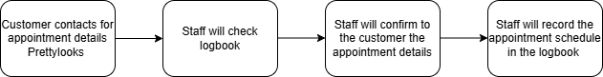

Figure 1 Setting Appointment

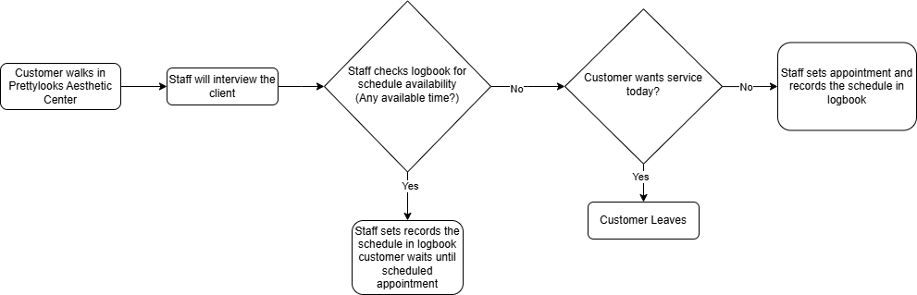

Figure 2 Accommodating Walk-ins

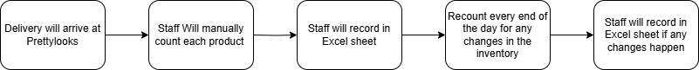

Figure 3 Recording Supplies



Figure 4 Accommodating Customer from Another Branch



Figure 5 Contacting Factory for Product



Figure 6 Data Entry of Customer Records

## 3.4 Gap Analysis

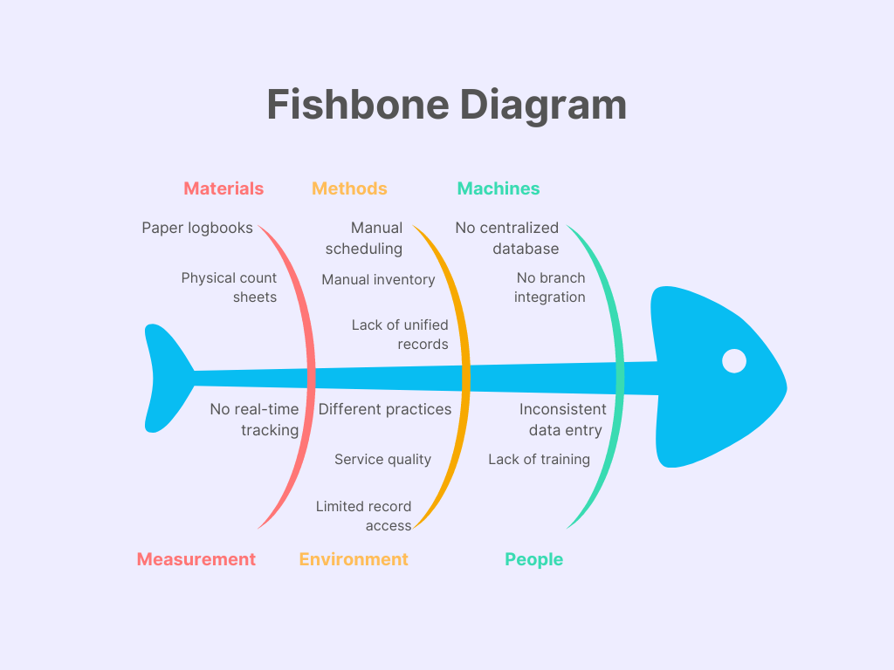

Figure 7 Fishbone Diagram

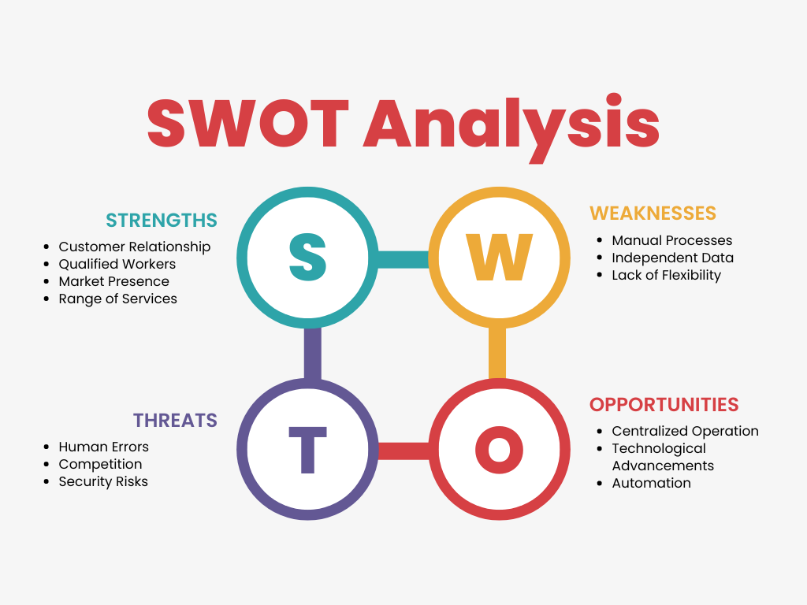

Figure 8 Fishbone Diagram

Table 2 Gap Analysis

|  |  |  |
| --- | --- | --- |
| Current State | Desired State | Impact |
| P001 | Automated Schedule Setting System | Improves employee’s convenience in recording appointments |
| P002 | Branches can view other branches appointment schedules | To retain and recommend the customer to other available branches |
| P003 | Automated inventory monitoring | Ensures real-time visibility of inventory levels, reducing stockouts and overstock situations. |
| P004 | Can verify customer records in a centralized database | Provides quick access to accurate customer information across all branches, enhancing personalized customer service and improving customer retention. |
| P005 | Automated warning system | Can provide real-time alerts on low inventory to inventory manager to prevent stockouts. |
| P006 | Improved data storage system | This enhances data security and accessibility, and reliability. It ensures that information is stored efficiently and can be retrieved quickly. |

# Proposed Solution

## 4.2 Lean Canvas

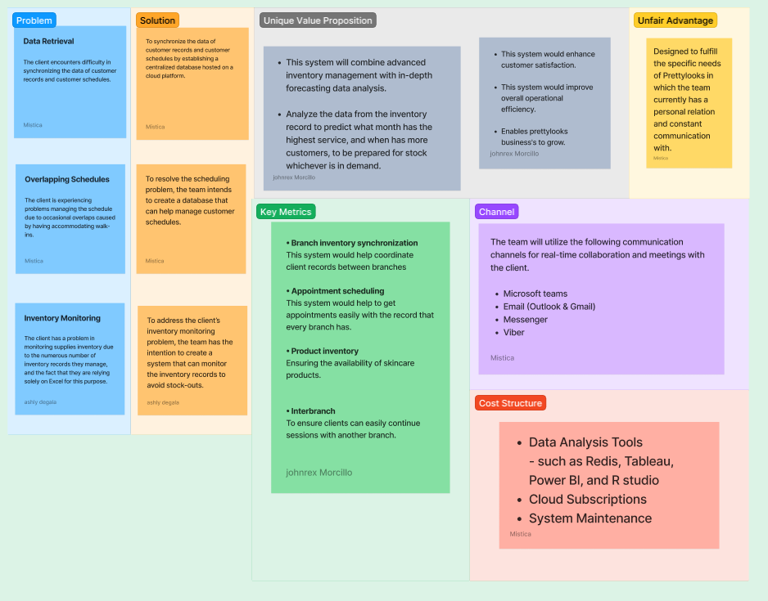

Figure 9 Lean Canvas

## 4.3 Product Vision

Table 3 Product Vision

|  |  |
| --- | --- |
| **For** | The staff at Prettylooks Aesthetic Centers |
| **Who** | Wants a centralized operation providing consolidated reports across different branches |
| **The** | MBOS is a system |
| **That** | Not only automates scheduling and inventory recording, but also allows the centers to work on a centralized operation by having consolidated reports of schedules, inventory, and customer records among the branches |
| **Unlike** | The independent data among branches with current process of manually recording appointment schedules in a logbook, physical counting of each product every delivery for inventory monitoring, and customer data record keeping |
| **Our Product** | Will consolidate data and reports among branches, as well as automate manual processes of recording schedules, recording supplies, and provide a secured system for recording and retrieving data |

## 4.4 Technology Specifications

The proposed Multi-Branch Operation System (MBOS) development and implementation will involve a thorough integration of several technologies, including hardware, software, peopleware, and network components. Below are the detailed specifications for each aspect:

**HARDWARE:**

1. **Servers:**

* **Cloud Server:** A fast server that can manage several requests from the user at once, hosting the database.
* **Back-up Server:** A secondary server primarily for data backup and redundancy to ensure data integrity and availability in case of a server failure.

1. **Network Equipment:**
   * **Router and Switches:** Enterprise-grade router and switches to manage and optimize network traffic.
   * **Devices:** Standard Windows computers, a minimum of a multi-processor (such as Intel Xeon), 16GB (gigabytes) of RAM (Random Access Memory), and SSD (Solid-State Drive) storage for quick data access are required.

**Software:**

1. **Operating System**
   * **Server OS:** Linux (Ubuntu server, CentOS) or Windows server for cloud and local backup servers.
   * **Client OS:** Windows 10/11 for desktops; iOS and android for mobile devices.
2. **Database Management System** 
   * A secure database management system like MySQL and Oracle Database will be chosen to store and manage patient information within the system. The specific choice will depend on factors such as scalability, security features, and team expertise.
3. **Security Protocols**
   * It is critical to put strong security measures in place. To safeguard patient data kept in the system, secure coding techniques, data encryption, and frequent security audits are necessary.
4. **Secure infrastructure**
   * Lightsail, an Amazon Web Services (AWS) platform, will host the system. The security of patient data on the online portal is guaranteed by this cloud-based technology. Depending on the selected virtual machine instance (vCPU, RAM, storage), Lightsail charges monthly a cost. The second tier, which will cost up to 700Php a month, will be used for this project.

**Peopleware:**

1. **Project Manager:**
   * Overseer of the whole development of the project. Their role includes assigning tasks for each member, managing the schedules and inventory and ensuring proper team communication.
2. **UI/UX Designer:**
   * The necessary interfaces for the suggested project are designed by the user interface (UI)/user experience (UX) designer. Ensuring a smooth user experience throughout the portal.
3. **Developers:**
   * Developers who have an adept knowledge of coding and are proficient in chosen web frameworks and technologies.
4. **Training and Support:**
   * Conducting training sessions for staff to freely use the system that was provided for them
   * Provide ongoing technical support for staff and customers alike.

**Network:**

1. **Internet Connection:** 
   * Secure internet connection. A reliable internet connection will be required for the team to access the development tools and cloud-based resources.
2. **Cloud Services:**
   * Using cloud services for scalability, backup, and data storage. For the project, platforms including Microsoft Azure, Google Cloud, and Amazon are considered.

## 4.5 Feasibility

**Operational Feasibility**

The system that was suggested to Prettylooks’ has a great chance of being implemented successfully. With Prettylooks’ management backing, it shows a clear vision for the project’s potential. Incorporating all employees and future customers in the design process will guarantee that the system fulfills their requirements.

Prettylooks itself will gain a great deal from this. Staff time can be freed up by automated scheduling and record-keeping, and overall efficiency and better treatment planning can be facilitated by better data management.

The potential benefits for patients include convenient online scheduling and secure treatment record. This can improve accessibility for customers who have a Prettylooks branch nearer than their first treatment. With the inclusion of treatment records, we can further satisfy the customers as it is no longer necessary to tell the staff what kind of treatment they want.

**Economic Feasibility**

The economic outlook for Prettylooks’ proposed system is promising, with potential long-term financial gains outweighing the initial investments needed. While upfront costs include the development of the system, hardware, software, and potential IT staff additions, the benefits offer a compelling return. Increased efficiency through online scheduling and record-keeping can free up time for the doctors, leading to cost savings. Additionally, online scheduling and appointments can attract new patients, increasing revenue as well. With real-time tracking of inventory, it could also contribute to cost savings by potentially notifying the staff if the products are already out of stock or they still have plenty of stock to avoid overstocking of products.

**Technological Feasibility**

Bringing Prettylooks’ system to life is technically feasible, thanks to the current technology landscape and available expertise. Key to this feasibility is the accessibility of standard development tools, cloud-based infrastructure, and secure database management systems. The clinic’s existing network infrastructure will be assessed to determine if any upgrades are needed to ensure smooth and reliable internet access, crucial for system operation.

**Schedule Feasibility**

With careful planning and project management, it is possible to implement Prettylooks’ proposed system in a reasonable amount of time. A realistic development and implementation of timeline is estimated to be between 6-12 months. To ensure that the project stays on schedule, this timeline must be set with specific deliverables and milestones. Throughout a project, agile development approaches can be used to guarantee flexible and adaptable changes. Maintaining open lines of communication with the staff of the clinic and potential clients will keep everyone informed and involved. By allowing a wiggle room in the timeline, buffer time helps reduce the likelihood that outside circumstances may impede project progress and maintain schedule flexibility. Prettylooks can guarantee that the suggested system is implemented in a fair amount of time and achieves its long-term objectives by carefully taking into account the considerations and putting solid project management methods into place.

# Requirements Analysis

## Product Backlog / User Stories

Table 4 User Stories

|  |  |  |  |  |
| --- | --- | --- | --- | --- |
| **USER STORIES** | | | | |
| **ID** | **As a...** | **I want to be able to...** | **So that...** | **Priority** |
| **1** | Clerk | Manage customer schedule | I can add, delete, and update appointment schedules. | Must |
| **2** | Clerk | View the customer schedule from other branches | I can recommend customers to other available branches. | Must |
| **3** | Clerk | Manage doctor/artist schedule for Prettylooks | Not only can I recognize the availability of the doctor/artist and correctly set procedure schedules, but I can also inform the customer about the doctor/artist’s schedule. | Must |
| **4** | Clerk | Manage customer records | I can add, delete, and update customer records | Must |
| **5** | Clerk | View customer records from other branches | If a customer from another branch walks-in, I can view their record easily without the need to call through phone. | Must |
| **6** | Clerk | Log-in to the system | I can access the system based on my role. | Must |
| **7** | Clerk | View product inventory | I can monitor the stocks of the products being sold in my branch. | Must |
| **8** | Clerk | View the product inventory from other branches | If our branch is out-of-stock, I can recommend to the customer which branch has the stock they want. | Must |
| **9** | Inventory Manager | Manage inventory | I can add, delete, and update supplies inventory. | Must |
| **10** | Inventory Manager | Set the minimum supply unit | I can be warned of in case of low stocks based on the limit I set. | Must |
| **11** | Inventory Manager | View supplies inventory | I can monitor the inventory | Must |
| **12** | Inventory Manager | Log-in to the system | I can access the system based on my role. | Must |
| **13** | Branch Manager | Register account | In the event of a new employee arriving, I can add accounts based on the staff’s role. | Must |
| **14** | Branch Manager | Generate report of customer schedule, customer records, and supplies inventory | Maintain accurate records and make informed decisions based on the data analysis and insights. | Should |
| **15** | Branch Manager | Manage customer schedule | I can add, delete, and update customer records | Must |
| **16** | Branch Manager | View the customer schedule from other branches | I can recommend customers to other available branches. | Must |
| **17** | Branch Manager | Manage customer records | I can add, delete, and update customer records. | Must |
| **18** | Branch Manager | View the customer records from other branches | If a customer from another branch walks-in, I can view their record easily without the need to call through phone. | Must |
| **19** | Branch Manager | Manage inventory | I can add, delete, and update supplies inventory. | Must |
| **20** | Branch Manager | Log-in to the system | I can access the system based on my role. | Must |
| **21** | Owner | Generate performance analytics and insights of the branches | Maintain accurate records and make informed decisions based on the data analysis and insights. | Should |
| **22** | IT Administrator | Set account permissions | I can grant access based on the account’s user role | Must |
| **23** | IT Administrator | Register account | In the event of a new employee arriving, I can add accounts based on the staff’s role. | Must |
| **24** | IT Administrator | Manage account | I can add, delete, and update supplies inventory. | Must |
| **25** | IT Administrator | Log-in the system | I can access the system based on my role. | Must |
| **26** | IT Administrator | Manage customer schedule | I can add, delete, and update customer schedule | Must |
| **27** | IT Administrator | Manage customer records | I can add, delete, and update customer records | Must |
| **28** | IT Administrator | Manage Inventory | I can add, delete, and update supplies inventory. | Must |

## Use Case Diagram

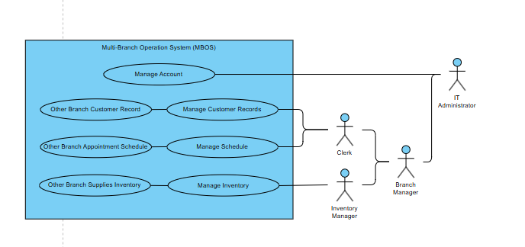

Figure 10 Use Case Diagram

## User Classes and Characteristics

Table 5 User Classes and Characteristics

|  |  |
| --- | --- |
| *Roles* | *Description* |
| *Clerk* | *This user is involved in managing customer schedules by adding, deleting, and updating appointment schedules. This role is responsible recommending customers to other branches when necessary and coordinating doctor/artist schedules at Prettylooks, ensuring accurate procedure scheduling and informing customers about availability. Additionally, this role can view customer records across branches, facilitating easy access without needing to call other branches, as well as monitor product inventory in their branch and recommend alternative branches to customers if items are out of stock locally.* |
| *Inventory Manager* | *This user is responsible for supervising all aspects of inventory management within the system. This includes tasks such as adding, deleting, and updating supplies in the inventory. The user can also set the minimum threshold for each supply unit, ensuring they receive alerts when stocks fall below this limit. Then the role can continuously monitor the inventory levels, facilitating proactive management and ensuring enough stock availability to meet operational needs.* |
| *Branch Manager* | *This user has the role of overseeing branch operations within the system. The user is responsible for registering accounts for new employees based on their roles, ensuring access and permissions are appropriately managed.* |
| IT Administrator | *This user has control over the system, enabling the role to oversee and execute tasks related to inventory management, customer record handling, scheduling, and account registration and management.* |

## Prototype

### 

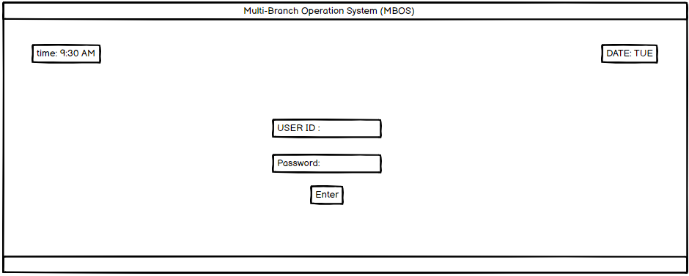

Figure 11 Sign-in

Figure 12 Home Page

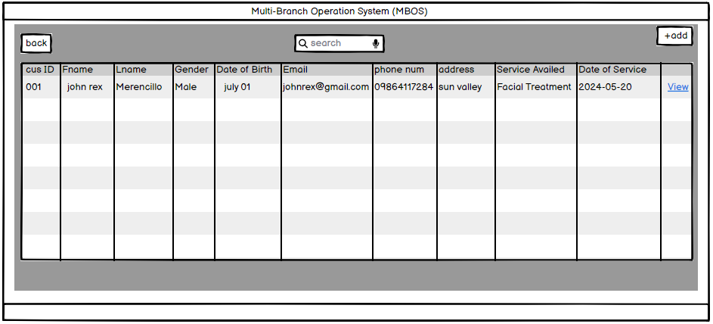

Figure 13 Customer Records Page

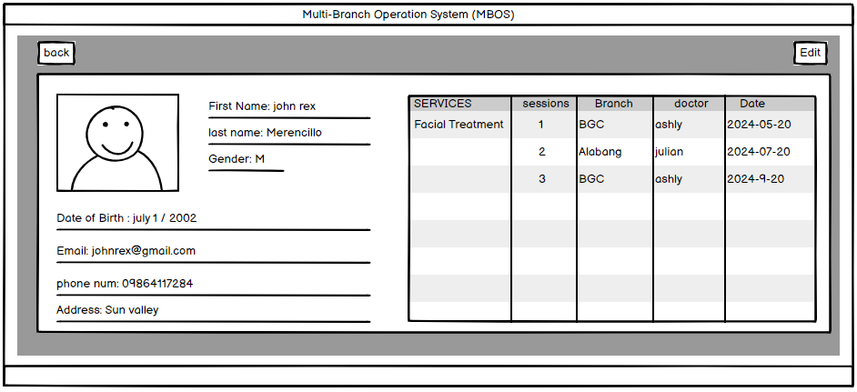

Figure 14 Viewing a Customer Record

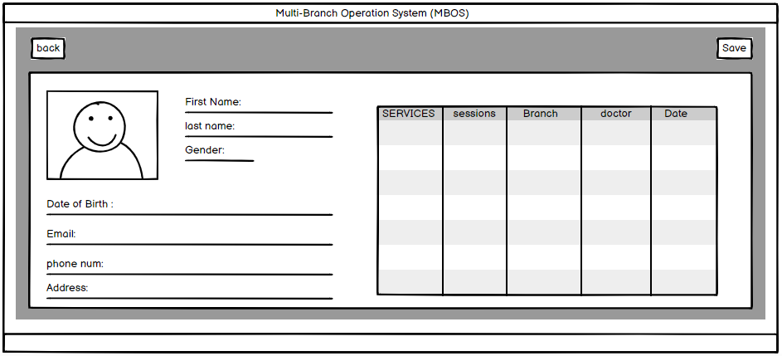

Figure 15 Editing a Customer Record

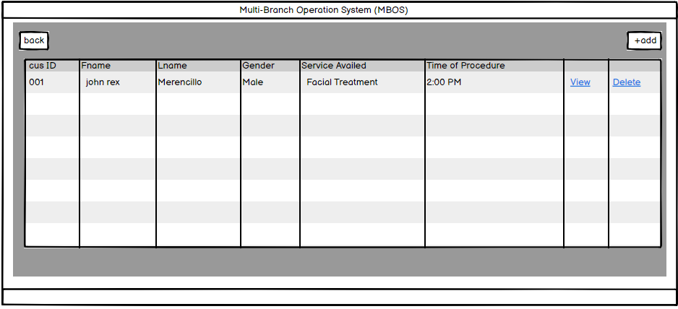

Figure 16 Customer Schedule Page

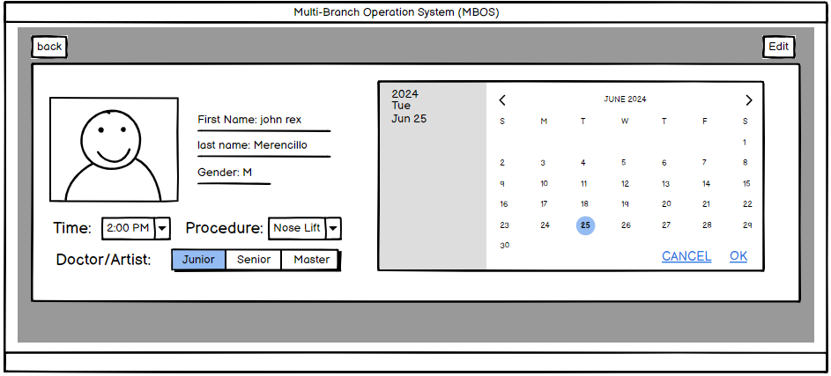

Figure 17 Viewing a Customer Schedule

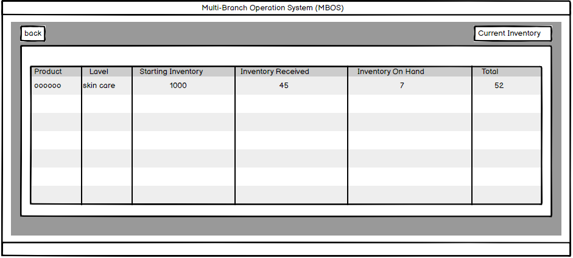

Figure 18 Inventory Records Page

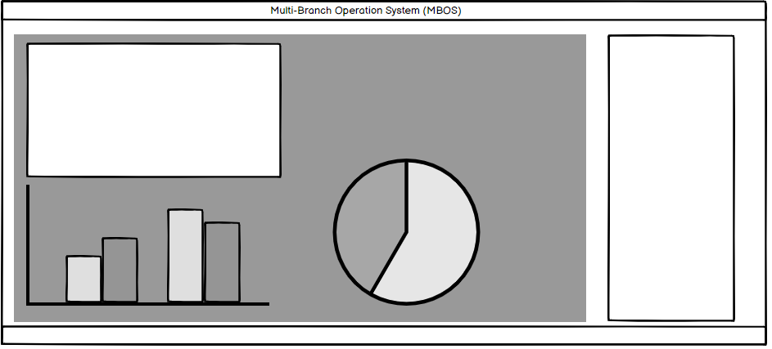

Figure 19 Generate Report Page

## 5.7 Release Plan

#### **Phase 1: Planning**

**Front End Development**

* + Develop the user interface and experience (UI/UX) for the system.
  + Create initial wireframes and prototypes.
  + Conduct usability testing and gather feedback.

**Database Development**

* + Set up initial database infrastructure.
  + Ensure data storage requirements are met.
  + Begin populating the database with initial data.

#### **Phase 2: Design**

**Design Database**

* + Finalize database schema and relationships.
  + Optimize database performance.
  + Implement security measures for data protection.

**Implementation**

* + Integrate front end and back end systems.
  + Develop core functionalities of the system.
  + Conduct initial integration testing.

**System Programming**

* + Write and test system code.
  + Implement additional features and functionalities.
  + Perform code reviews and debugging.

#### **Phase 3: Testing and Deployment**

**System Testing**

* + Conduct comprehensive testing of the entire system.
  + Perform user acceptance testing (UAT) with stakeholders.
  + Fix bugs and issues identified during testing.

**Full Deployment and Optimization**

* + Deploy the system to the production environment.
  + Monitor system performance and optimize as needed.
  + Provide training to end users and administrators.

# References

[1]“(PDF) WEB - BASED INTELLIGENT INVENTORY MANAGEMENT SYSTEM,” ResearchGate. <https://www.researchgate.net/publication/317276986_WEB_-_BASED_INTELLIGENT_INVENTORY_MANAGEMENT_SYSTEM>

‌[2]T. Sheakh, “(PDF) A Study of Inventory Management System Case Study,” ResearchGate, 2018. <https://www.researchgate.net/publication/327793184_A_Study_of_Inventory_Management_System_Case_Study>

[3]M. Ali and M. Asif, “(PDF) Inventory Management and Its Effects on Customer Satisfaction,” ResearchGate, Jul. 2012. <https://www.researchgate.net/publication/254410703_Inventory_Management_and_Its_Effects_on_Customer_Satisfaction>

# VII.

# Appendices

## Appendix A: Schedule/Release Plan

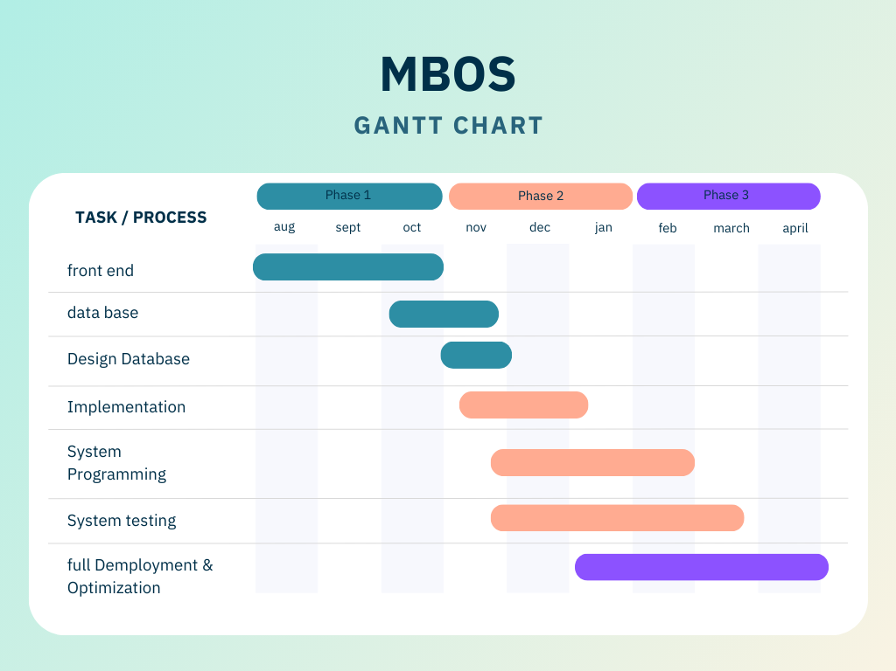

**Appendix B: Product Roadmap**

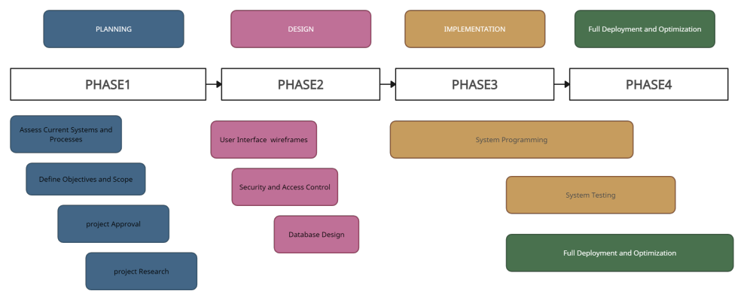

## Appendix C: Teams Meetings

Meeting with sir jojo for consultation

Jun 18, 2024 3:00 PM - 3:30 PM

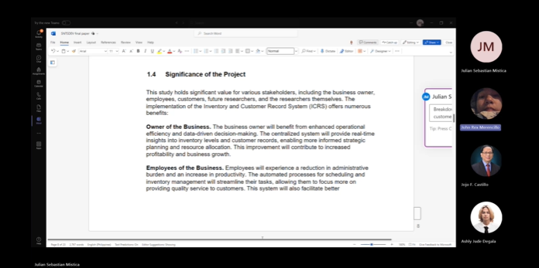

Meeting with miss roselle  
for consultation   
Jun 19, 2024 2:30 PM - 3:00 PM

